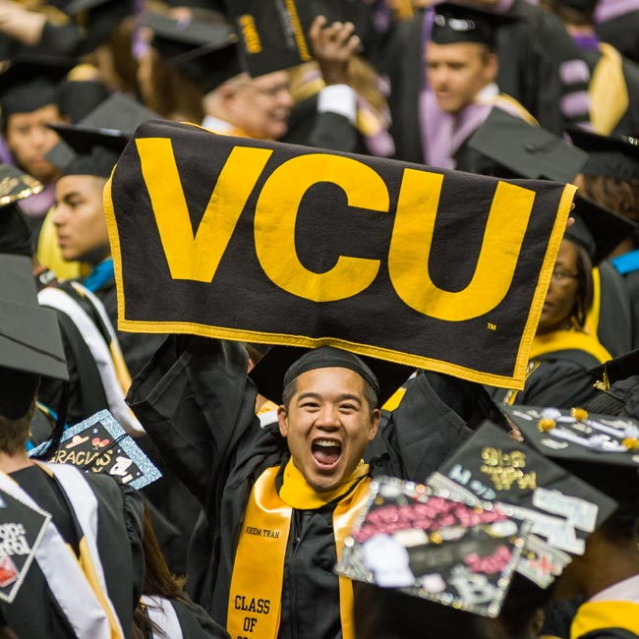

# FIRST–YEAR

# SEMINARS

______

1-CREDIT

______

FALL 2019

______

MENU

OF COURSES

# **Introduction to the University (UNIV 101)**

Designed to orient new students to the traditions, purposes and expectations of a university education. Students will assess their expectations and evaluate their academic strengths and goals. Students will learn of VCU resources designed to help them solve problems and to achieve a rewarding and successful academic program.

# **I Want to Get Involved on Campus But I Am Not Sure How?**

This course is for students seeking opportunities to find new friends who share like ideas or for students who know that they need to get out more socially and just are not sure where to start or what great opportunities exist on campus. During this course students explore VCU student clubs and organizations, leadership opportunities, VCU and RVA community events, and begin to open doors to where they can find their niche at VCU.

# **“I Can Get Help With That?” Stronger Study Strategies and Less Procrastination**

Come join us to learn how to make your study time count, get assignments done faster and learn all the ways VCU can help you with your academics. Topics include learning about tutoring, Supplemental Instruction, writing consultations, and fantastic (easy to do) study strategies. Say good-bye to wasted time and procrastination. This is a great way to decrease your academic stress and increase your productivity.

# **How Can I Pay For College?**

This course examines ways to budget your money, investigate private and public resources to finance your education, and research resources in your local communities to potentially secure additional dollars to make sure you can continue to afford your education.

# **Introduction to Career Planning & Management**

Find out how to connect your major to careers while learning more about yourself through guided self-exploration. Explore ways to gain experience while you are at VCU that will be useful to your future plans. Discover how you can start planning your career now and manage it long-term. We lay the foundation for a productive four-year graduation rate that leads to gainful and self-fulfilling employment!

# **Dynamic Principles for Professional Development: For Men of Color**

This class is designed to build community among men of color. Students explore internships and leadership opportunities on campus and focus on professional development. Each student is connected to a campus navigator to aid you in your adjustment to campus and a professional navigator, a person in your desired field of study. The class explores issues that men face in college and beyond through discussions and guest speakers.

# **Leadership Development for Women of Color** The purpose of the course is to empower undergraduate African-American women to break through the barriers that impedes their professional growth. Through in-depth discussions, engaging activities, guest speakers, and service projects, students will learn how to build their leadership brand, set SMART goals, and create a culture of collaboration, in order to become the leaders they were destined to be.

# **Navigating LGBTQ Pride at VCU and RVA**

This course is for students who want to connect and identify with their surrounding LGBT and ally community. Topics covered include an exploration and reflection of self and society through current events, local resources, and academic readings/films. This class welcomes members of the community and allies to engage in a timely, essential, and semester-long conversation.

# **Maximizing VCUarts Foundation**

This module provides students new to the VCUarts' Foundation program a more thorough guidance on the resources, opportunities and potential of VCUarts. Experience facility tours, visiting lecturers and unique introductions to major options while exploring arts career potential. Students also have an opportunity to actively navigate AFO-specific challenges with supportive peer and instructor feedback.

# **Maximizing Your Study Abroad**

This course is designed for students majoring in any field who are interested in incorporating a study abroad experience into their degree at VCU. This course will introduce students to global education experiences available at VCU and will prepare students for cross-cultural engagement. Students learn how to successfully navigate the logistics of study abroad including program and funding opportunities. Students also gain skills to prepare them to live and study in a country and culture other than their own in order to maximize the study abroad experience for long-term academic and professional development and personal enrichment. Students who successfully complete this course receive $500 towards the cost of a study abroad experience from the Global Education Office!

**Urban Education and Experience**  
In this course students will have the opportunity to explore the challenges of access and equality in urban educational settings. Engage in discussions around how personal identity impacts educational experience. Students will actively participate and learn about grass-roots projects that help the Richmond community.

**The Science of Recovery**  
VCU loves students in recovery from addiction. Learn about the science of recovery, build recovery skills, learn about resources in our community and beyond, and find meaningful ways to be of service. Through lectures, guest speakers and individual projects, students will learn of VCU resources designed to help them in their recovery and build a rewarding and successful life and career.

# **Finding Your Voice**

Were you involved in your high school yearbook or newspaper? Do you like discovering new music and podcasts? Are you into comics, sports, fashion, creative writing, photography, art, design, or video? Learn about all of the opportunities provided by the VCU Student Media Center and our student-run media outlets, and how you can get involved. Whether it’s related to your major and you want to start building a portfolio, or you just need a creative outlet on campus, this is where you can find both your voice and your community of like-minded people.

**Profiles in Leadership: Deepening your Influence at VCU**

Leadership changes the world! This class will introduce students to leadership from a variety of viewpoints/perspectives and discuss how to deepen their influence in the VCU community and beyond. Students will discuss the ways in which their own leadership development can contribute to their success both in and outside of the classroom.

# **From Locker Room to Classroom**

Were you a high school athlete? Do you have a passion for sports and physical fitness? Many of the skills you use in these areas can also encourage academic success. This course provides tangible opportunities for students to forge connections between athletic experiences and academic success and consider how they can continue to pursue their passion for sport and fitness both outside and inside the classroom.

**Getting Connected**  
This course helps students discover opportunities for civic engagement in VCU and the Greater Richmond community.  This community-based class is for first-year students across the volunteer spectrum. If you’re a hands-on learner or ready to develop your résumé, if you’re interested in human rights, social justice, or just getting out of your comfort zone, if you’re wondering how to immerse yourself at an urban institution like VCU, this course is for you.

**Professional Planning for Pre-Nursing Majors**  
This course is designed for pre-nursing students and course topics will include how to be a competitive candidate for the nursing application process, investigating multiple pathways to the Nursing profession, and exploring additional healthcare and helping related fields. Students will learn how to navigate the high school to college transition through utilizing university resources and setting academic and professional goals.

**Undergraduate Options in Healthcare**  
This course is designed for pre-health students majoring in the pre-majors of Clinical Lab Sciences, Dental Hygiene, or Radiation Sciences.  This class will help students explore each of these fields, develop strategic plans for future application to these professional programs, and also explore a variety of other options in healthcare and related fields. Students will learn how to navigate the high school to college transition through utilizing university resources and setting academic and professional goals.​

**F.I.R.S.T Generation in Healthcare**  
The journey to obtaining admission to a health professions program can be overwhelming.  If you are the 1st person in your family to attend an institution of higher education, the road to a healthcare profession can seem almost unattainable.  Do you know what it takes to become a healthcare professional? This course is designed to help pre-professional health students who are 1st generation in college to be F.I.R.S.T. in Healthcare - **F**ocused, **I**nspired, **R**esourceful, **S**uccessful and **T**ogether.  Students will learn how to network with healthcare professionals, research professional and financial resources, develop critical thinking and ethical reasoning skills and stay motivated through the healthcare journey.